



CASE STUDY

DAI Bench LCT - GCP Data Engineer

**Learning & Talent Transformation**

# Introduction

[Strava](https://www.strava.com/features) (strive for better) is a health & fitness app for the community of health and fitness enthusiasts. Over 100 million athletes in 195 countries use Strava with a growth rate of 2 million users per month. Strava offers to keep track of all your health activities and gives you the ability to analyze them. More importantly it allows you to connect with your friends on a social media like platform to get inspired or inspire others on health and fitness regime. The social aspects of Strava are the real differentiators amongst all community apps in the health and fitness category. The recently added gamification features has resulted into increase into of active users on the platform. Strava is a universal platform that anyone can use (professional athletes, budding athletes, amateurs) regardless of how they capture their health activities i.e., directly on the app or via personal health and fitness devices

# Key Features of Strava

The key features of Strava are broadly categorized into

## Track and Analyze Activities

This feature gives the ability to track activities on Strava. It can track multiple activity types like walking, running, cycling, hiking and swimming. It can track activity at a granular level (for example each step that you take as you walk). Walking and running are the two most popular activities amongst the users of this platform. For example, a walk activity looks as follows and can track distance travelled, elevation gained, and time taken. In the background it also tracks start location and time, stop location and time, and plots a geo map of your activity. Activities can automatically be tracked by the app or it can be relayed/synched from any other health and fitness devices. Once tracked you can analyze these activities to get insights which will help you track and achieve your fitness goals.

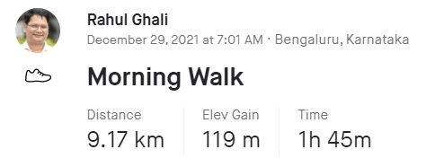

## 

## Publish Activity Feeds

### Manage your profile

Strava being a community app for health users, it has social features like following other users. It maintains your profile which depicts your personal and demographic information, the people you follow (referred as Following), people who follow you (referred as Followers) and a count of all activities you have performed so far.

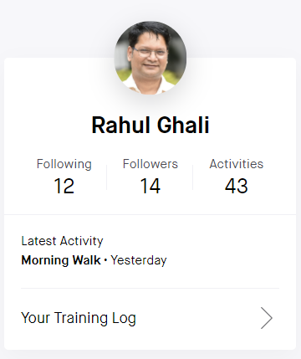

### Activity Feeds

Apart from your profile, you can see your own activities in your activity feed, and you can also see the activities of everyone that you follow on Strava. The feed is sorted by time and each feed shows activity details such as name of the person, activity tag, distance travelled etc... You also get the ability to give comments and kudos to an activity that shows up in your feed. You can share a given activity on other social media platforms like Twitter, Facebook etc.

## 

## Track and Analyze Activities

## Publish Activity Feeds=

## Publish Activity Feeds

## Setup a Challenge

## Setup a Challenge

This is a newly added gamification feature and has led to an exponential increase in the userbase of this platform. This feature allows you to set up a health challenge (public or private challenge) and invite members on the platform to join the challenge. The challenge is defined for a given time and has a set goal. For example, a challenge with a goal of collective walking for *<<18,000 KM’s>>* in a window of <<30 days>>. Or it could be a challenge with a goal of collectively clocking <<300>> hours of walking in a window of <30 days>. There is a leader board associated with each challenge. This leader board needs to be updated in real time.

